Today:

Starburst Enterprise Presto (**SEP**):

 presto distribution

 connecters (mission control)

 security

 support

Next:

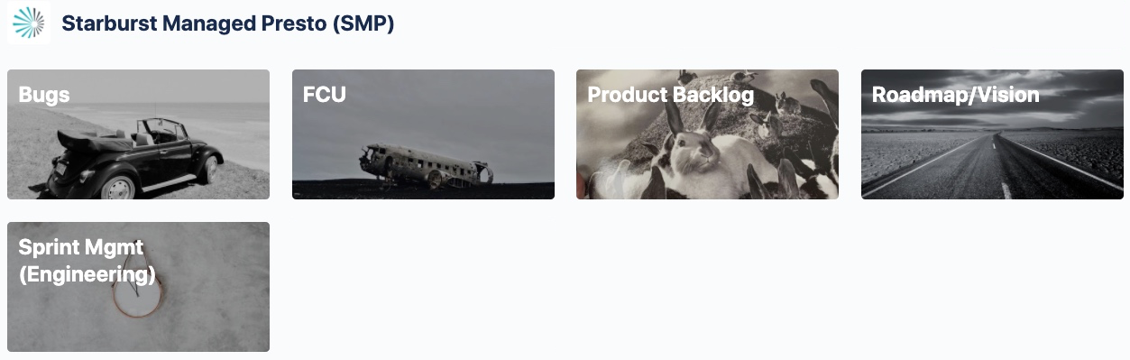

Starburst Managed Presto (**SMP**) Services:

consumes/replaces **SEP** +

* + expert managed deployment
  + managed BI tools
  + managed AI/ML tools
  + [Starburst Dark Matter](https://www.starburstdarkmatter.com/) - **SDM\***:
    - object storage
    - RDBMS
    - NoSQL
    - eMR (Hadoop etc.)
    - Kubernetes

Starburst Managed Presto (**SMP**) Product Boards:

* [Roadmap & Vision](https://trello.com/invite/b/ZBG9EjyH/f72cde97d5d35cd241e7f2606d4f18f3/roadmap-vision)
* [Sprint Management](https://trello.com/invite/b/uRR8209k/3c6bfb7cb635af35d99cf04d890f0258/sprint-mgmt-engineering)
* [Product Backlog](https://trello.com/invite/b/BsU1GsbV/3997bf7714972a71c62008bfde6d6deb/product-backlog)
* [Fixes, Changes, Updates (FCU)](https://trello.com/invite/b/XeyIAgth/ae7dc89e3d921fc0ce7acea7a8dae258/fcu)
* [Bugs](https://trello.com/invite/b/bvdAfFTm/1b30f17504aca0a8c6ae88edced685f4/bugs)

*\* Dark matter comprises 85% of all matter in the known universe. Starburst Dark Matter is enterprise cloud storage except far above the cloud. Bypass the constraints (and costs) of known cloud storage options. It is not compute. It is not 164 other cloud services. It is object, RDBMS, NoSQL & eFS storage & queries. As the foundation for Starburst Managed Presto (SMP) Services, it is the ‘future-is-now’ solution for data access & analysis.*